# Modelo E/R

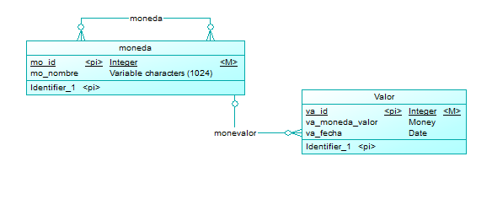

# phpmyadmin

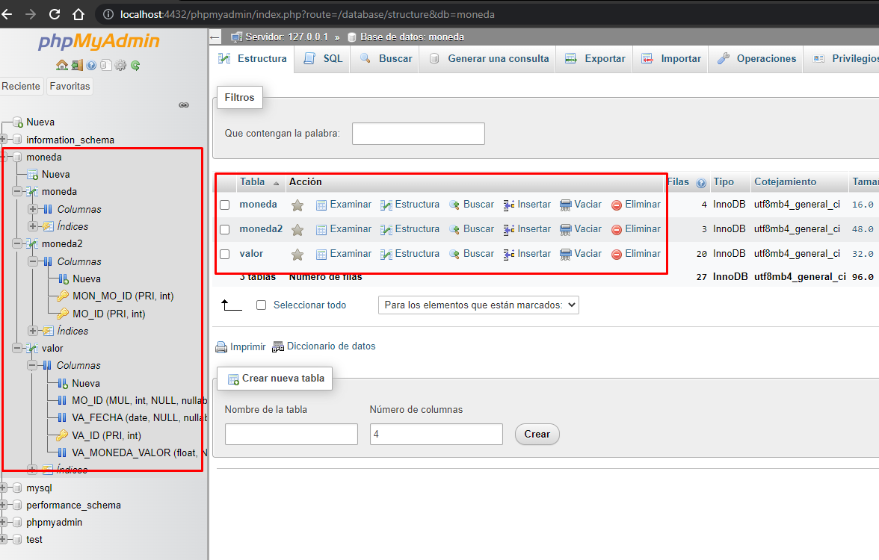

# Complication

